CDN Usage

Definition
# Source: AI Source: Provided by: [Data Path: Persons Table -> ID Column: 1, Name_En Column: Motasem Essam] -> From: [Chatgpt (GPT‑5 Mini)] on [2/12/2026]
CDN Usage (Content Delivery Network Usage) is a performance optimization technique that delivers website content from multiple servers located in different geographic locations, so users receive data from the nearest server.

Simple Definition
# Source: AI Source: Provided by: [Data Path: Persons Table -> ID Column: 1, Name_En Column: Motasem Essam] -> From: [Chatgpt (GPT‑5 Mini)] on [2/12/2026]
Using CDNs = delivering website content from the closest server to make it load faster.

How Using CDNs Works
# Source: AI Source: Provided by: [Data Path: Persons Table -> ID Column: 1, Name_En Column: Motasem Essam] -> From: [Chatgpt (GPT‑5 Mini)] on [2/12/2026]
• Website files (images, CSS, JavaScript) are stored on multiple servers worldwide
• When a user visits the website, content is delivered from the nearest server
• This reduces the distance data travels
• Improves loading speed and reliability

Purpose of Using CDNs
# Source: AI Source: Provided by: [Data Path: Persons Table -> ID Column: 1, Name_En Column: Motasem Essam] -> From: [Chatgpt (GPT‑5 Mini)] on [2/12/2026]
• Improve website loading speed
• Reduce server load
• Deliver content faster globally
• Improve user experience
• Increase website availability and reliability

Advantages
# Source: AI Source: Provided by: [Data Path: Persons Table -> ID Column: 1, Name_En Column: Motasem Essam] -> From: [Chatgpt (GPT‑5 Mini)] on [2/12/2026]
• Faster loading for users worldwide
• Reduces load on the main server
• Improves performance and speed
• Better handling of high traffic
• Increases reliability and uptime

Disadvantages
# Source: AI Source: Provided by: [Data Path: Persons Table -> ID Column: 1, Name_En Column: Motasem Essam] -> From: [Chatgpt (GPT‑5 Mini)] on [2/12/2026]
• Can be costly for large usage
• Requires setup and configuration
• Less control over external servers
• Possible caching issues (outdated content)
• Depends on third-party services

Examples
# Source: AI Source: Provided by: [Data Path: Persons Table -> ID Column: 1, Name_En Column: Motasem Essam] -> From: [Chatgpt (GPT‑5 Mini)] on [2/12/2026]
• Loading images and videos from global servers
• Serving CSS and JavaScript files via CDN
• Popular CDNs like Cloudflare or AWS CloudFront
• Faster access to content from different countries

Difference Between CDNs and Other Techniques
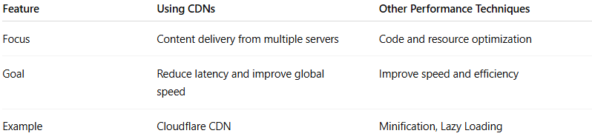
Feature | Using CDNs | Other Performance Techniques
Focus | Content delivery from multiple servers | Code and resource optimization
Goal | Reduce latency and improve global speed | Improve speed and efficiency
Example | Cloudflare CDN | Minification, Lazy Loading

